O’ZBEKISTON RESPUBLIKASI OLIY TA’LIM, FAN VA INNOVATSIYA VAZIRLIGI
ABU RAYXON BERUNIY NOMIDAGI URGANCH DAVLAT UNIVERSITETI

Kompyuter injineringgi fakulteti
„Kompyuter ilmlari va dasturlash texnologiyalari” yo’nalishi 234-guruh
Razzaqova Ro’zaxonning
“Web texnologiya ” fanidan
10-laboratoriya mashg’uloti

Qabul qildi: ________________________________________________

Urganch-2025

Labоratоriya ishi №10
Mavzu: CSS transition va animatsiya elementlarini yaratish.
Maqsad:
Veb-sahifadagi elementlarning silliq o‘tishlari (transition) va murakkab harakatlari (animation)ni CSS yordamida yaratish ko‘nikmalarini shakllantirish.
Nazariy ma’lumot
CSS Transition (o‘tish effekti)
CSS transition — elementning bir holatdan boshqa holatga asta-sekin o‘tishini ta’minlaydi. Masalan, rang, o‘lcham, joylashuv, shaffoflik va h.k.
Transitionning asosiy xossalari
Property | Tavsifi
transition-property | Qaysi xususiyat o‘zgarishi ko‘rsatiladi
transition-duration | O‘tish davomiyligi
transition-timing-function | O‘tish tezlanish egri chizig‘i
transition-delay | O‘tishni boshlashdan oldingi kutish
Transition misol:
.box {
width: 100px;
height: 100px;
background: blue;
transition: background 0.5s, transform 0.5s;
}
.box:hover {
background: red;
transform: scale(1.2);
}
CSS Animation (animatsiya)
Animation — elementning bir necha bosqich (keyframe) orqali dinamik harakatlanishini ta’minlaydi.
Animationning asosiy xossalari:
Property | Tavsifi
@keyframes | Animatsiya bosqichlari
animation-name | Animatsiya nomi
animation-duration | Davomiyligi
animation-timing-function | Harakat egri chizig‘i
animation-delay | Kechikish
animation-iteration-count | Necha marta takrorlanadi
animation-direction | Yo‘nalishi (normal, reverse, alternate)
Animation misol:
@keyframes move {
0% { transform: translateX(0); }
50% { transform: translateX(150px); }
100% { transform: translateX(0); }
}
.ball {
width: 50px;
height: 50px;
background: red;
border-radius: 50%;
animation: move 2s infinite;
}
Amaliy qism.
Html kodi.
<!DOCTYPE html>
<html lang="uz">
<head>
<meta charset="UTF-8">
<title>Xiva — Zamonaviy animatsion sahifa</title>
<!-- Font Awesome ikonkalar -->
<link rel="stylesheet" href="https://cdnjs.cloudflare.com/ajax/libs/font-awesome/6.5.0/css/all.min.css">
<style>
body{
margin: 0;
font-family: "Poppins", sans-serif;
background: #eef3f6;
color: #333;
overflow-x: hidden;
}
.header{
background: url('https://upload.wikimedia.org/wikipedia/commons/0/00/Itchan_Kala.jpg') center/cover no-repeat;
height: 55vh;
display: flex;
justify-content: center;
align-items: center;
color: white;
text-shadow: 0 3px 10px rgba(0,0,0,0.6);
animation: fadeDown 1.5s ease-out;
position: relative;
}
@keyframes fadeDown {
from{opacity:0; transform: translateY(-50px);}
to{opacity:1; transform: translateY(0);}
}
.header h1{
font-size: 3rem;
background: rgba(0,0,0,0.4);
padding: 15px 30px;
border-radius: 12px;
backdrop-filter: blur(3px);
}
.float-icon{
position: absolute;
font-size: 2.5rem;
opacity: 0.9;
animation: float 5s ease-in-out infinite;
color: #70bebb;
}
.icon1{ top: 20%; left: 10%; animation-delay: 0s; }
.icon2{ top: 65%; left: 80%; animation-delay: 1.2s; }
.icon3{ top: 30%; left: 60%; animation-delay: 2s; }
.icon4{ top: 15%; left: 50%; animation-delay: 0.5s; }
.icon5{ top: 70%; left: 20%; animation-delay: 1.8s; }
.icon6{ top: 40%; left: 85%; animation-delay: 2.5s; }
.icon7{ top: 80%; left: 60%; animation-delay: 1s; }
.icon8{ top: 10%; left: 30%; animation-delay: 2.2s; }
.icon9{ top: 55%; left: 5%; animation-delay: 3s; }
@keyframes float {
0%{ transform: translateY(0); }
50%{ transform: translateY(-25px); }
100%{ transform: translateY(0); }
}
.container{
max-width: 1000px;
margin: 40px auto;
padding: 0 20px;
}
.card{
background: white;
padding: 30px;
border-radius: 20px;
box-shadow: 0 6px 25px rgba(0,0,0,0.15);
transition: transform 0.4s, box-shadow 0.4s;
animation: fadeUp 1s ease;
margin-bottom: 40px;
}
.card:hover{
transform: scale(1.03);
box-shadow: 0 15px 35px rgba(0,0,0,0.25);
}
@keyframes fadeUp {
from{opacity:0; transform: translateY(60px);}
to{opacity:1; transform: translateY(0);}
}
.card img{
width: 100%;
border-radius: 15px;
margin-bottom: 20px;
transition: transform 0.5s, filter 0.4s;
}
.card img:hover{
transform: scale(1.08);
filter: brightness(1.15);
}

h2{
color: #00796b;
}
p{
line-height: 1.7;
font-size: 1.05rem;
}
.btn{
display: inline-block;
margin-top: 20px;
padding: 12px 25px;
background: #009688;
color: white;
border-radius: 10px;
text-decoration: none;
font-weight: bold;
transition: background 0.4s, transform 0.4s, box-shadow 0.4s;
box-shadow: 0 4px 12px rgba(0,150,136,0.3);
}
.btn:hover{
background: #00bfa5;
transform: scale(1.1);
box-shadow: 0 8px 20px rgba(0,200,170,0.5);
}
.icon-section{
display: flex;
justify-content: space-around;
margin: 60px 0;
animation: fadeUp 1.5s ease;
}
.icon-box{
text-align: center;
background: white;
padding: 20px;
width: 30%;
border-radius: 15px;
transition: transform 0.4s, background 0.4s;
box-shadow: 0 4px 15px rgba(0,0,0,0.12);
}
.icon-box:hover{
transform: translateY(-12px) scale(1.05);
background: #e0f2f1;
}
.icon-box i{
font-size: 3rem;
color: #00897b;
margin-bottom: 10px;
transition: transform 0.4s;
}
.icon-box:hover i{
transform: rotate(10deg) scale(1.15);
}
</style>
</head>
<body>
<!-- HEADER -->
<div class="header">
<h1>Xiva — Sharqning tirik tarixi</h1>
<!-- Floating icons -->
<i class="fa-solid fa-mosque float-icon icon1"></i>
<i class="fa-solid fa-star float-icon icon2"></i>
<i class="fa-solid fa-landmark float-icon icon3"></i>
<i class="fa-solid fa-moon float-icon icon4"></i>
<i class="fa-solid fa-jar float-icon icon5"></i>
<i class="fa-solid fa-mountain-sun float-icon icon6"></i>
<i class="fa-solid fa-shapes float-icon icon7"></i>
<i class="fa-solid fa-fire float-icon icon8"></i>
<i class="fa-solid fa-compass float-icon icon9"></i>
</div>
<div class="container">
<div class="card">
<img src="https://uzbekistan.travel/storage/app/media/Otabek/Kalta%20minor./cropped-images/xiva-otmishga-ochilgan-vaqt-darvozasi-0-0-0-0-1724238644.jpg">
<h2>Xiva haqida</h2>
<p>
Xiva — O‘zbekistonning eng go‘zal tarixiy shaharlaridan biri. Shahar o‘zining Ichan-Qal’a
majmuasi bilan mashhur bo‘lib, qadimiy Ipak yo‘lida joylashgan. Bu yerda madrasalar,
minoralar, saroylar va masjidlar bir butun tarixiy ansamblni tashkil etadi.
</p>
<a class="btn" href="#">Batafsil ma’lumot</a>
</div>
<div class="icon-section">
<div class="icon-box">
<i class="fa-solid fa-monument"></i>
<h3>Tarixiy obidalar</h3>
<p>Xivada 50 dan ortiq tarixiy inshootlar mavjud.</p>
</div>
<div class="icon-box">
<i class="fa-solid fa-map-location-dot"></i>
<h3>Ichan-Qal’a</h3>
<p>UNESCO merosi ro‘yxatiga kiritilgan noyob shahar.</p>
</div>
<div class="icon-box">
<i class="fa-solid fa-users"></i>
<h3>Turizm markazi</h3>
<p>Har yili minglab sayyohlar Xivaga tashrif buyuradi.</p>
</div>
</div>
</div>
</body>
</html>
Kodni natijasi.
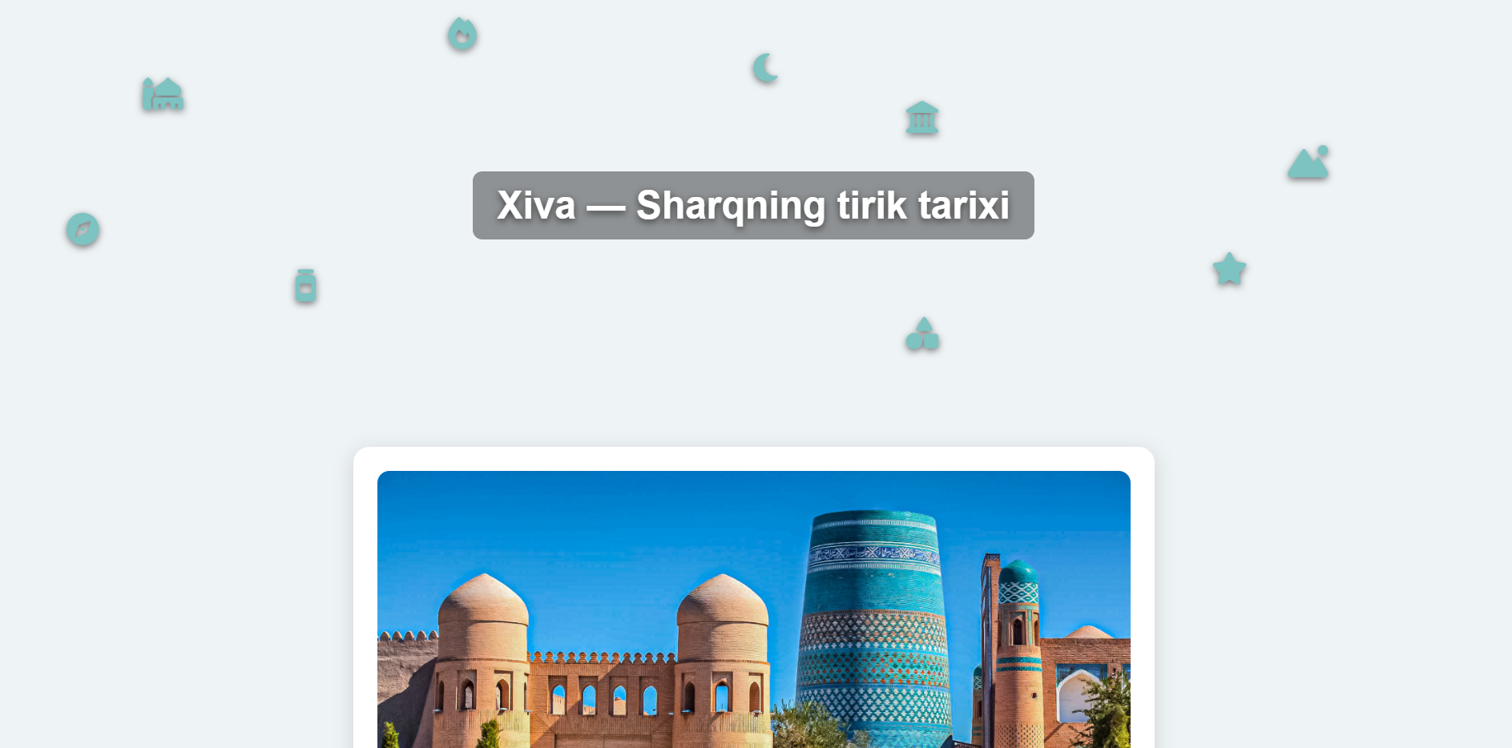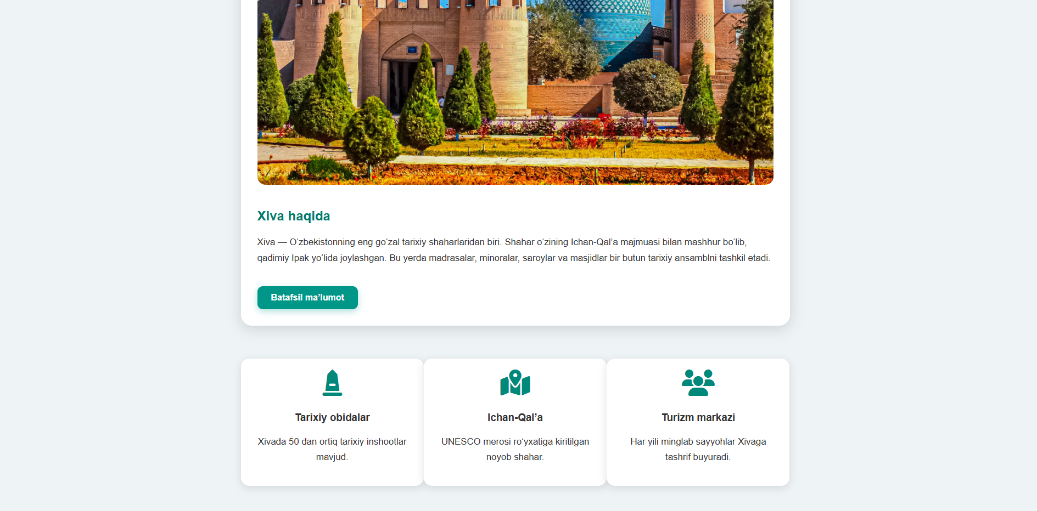
Xulosa
Ushbu laboratoriya mashg‘ulotida CSS transition va animation texnologiyalaridan foydalanib, veb-sahifadagi elementlarga silliq, chiroyli va dinamik effektlar berish ko‘nikmalari mustahkamlandi. Amaliy ish davomida HTML tuzilmasi asosida sahifa yaratilib, unga turli animatsion effektlar qo‘llandi. Xususan:
- Transition yordamida elementlarning ustiga sichqoncha olib borilganda ularning o‘lchami, soyasi, rangi va yorqinligi silliq o‘zgarishi ta’minlandi.
- Animation orqali sahifaga kirishda elementlarning pastdan yoki yuqoridan silliq ko‘rinib chiqishi, shuningdek, ikonkalarning tebranib turuvchi harakatlari (float effekti) tashkil qilindi.
- @keyframes qoidasi yordamida bir nechta bosqichli animatsiya yaratildi va ular elementlarga biriktirildi.
- Tayyor sahifa misolida animatsiya va transitionlarning real loyihalarda — bannerlar, kartalar, ikonlar va rasm ustida ishlatilishining amaliy ahamiyati ko‘rsatildi.
Natijada CSS animatsiyalarining asosiy tamoyillari, ularning qo‘llanilishi, vaqt funksiyalari, takrorlanish xususiyatlari va dizayndagi o‘rni bo‘yicha amaliy tajriba hosil qilindi. Ushbu mashg‘ulot kelajakdagi veb-proyektlarda zamonaviy, interaktiv va jozibali interfeyslarni yaratishda muhim dastak bo‘lib xizmat qiladi.

